BPM Package Installation

# Purpose

This document is intended to show how to install a package to testing or production BPM environments.

# Scope

This document covers the steps of installing a clean BPM online version with all its prerequisites. It also describes how to configure and use the installation tools (batch files). In addition to the configuration needed in order to communicate with the Smart Order Manager (SOM).

# Revision History

|  |  |  |  |  |
| --- | --- | --- | --- | --- |
| **S.No** | **Date** | **Change Description** | **Document Version** | **Prepared By /Modified By** |
| 1 | 26 – Feb - 2019 | First version | 1.0 | Mortada Issa |
|  |  |  |  |  |
|  |  |  |  |  |
|  |  |  |  |  |

# Installing BPM

In order to install BPM online, you have to get a zipped BPM Online Package and configure some prerequisites on the target environment.

This link is share by BPM online academy on how to install BPM on site <https://academy.bpmonline.com/documents/marketing/7-7/installing-bpmonline-application-site?document=marketing>

Below are some notes that might be helpful:

1. Use WinRAR to extract the package and do not use the tools installed by default on windows
2. If you have multiple applications installed on the same environment, they will be sharing the same REDIS server. Then make sure to increment the DB counter in the application configuration file

# Preparing the Installation Tool

After installing BPM and making sure it is running, we have to prepare first the work space tool. In order to do this go to installation path under Terrasoft.WebApp\DesktopBin\WorkspaceConsole

Run the PrepareWorkspaceConsole.x64 or 86 according to your environment (it is recommended to run it as an administrator).

This batch file will prepare work space utility to be ready for use. Get the installPackage batch file from the shared environment \\192.168.110.185\Fixes\BPM\InstallationTools

Copy the saved package folder into your environment \\192.168.110.185\Fixes\BPM\20190225

Then update the following parameters in the install package batch file:

1. Change the path that leads to WorkSpaceConsole.exe
2. sourcePath: points to SavedPackages folder
3. destinationPath: create a TempPackages folder and point to it
4. webApplicationPath: points to the root installation folder
5. confRuntimeParentDirectory: points to the Terrasoft.WebApp folder under root folder
6. logPath: create a folder called Log and points to it

You have to also copy the buildConfiguration from the following directory \\192.168.110.185\Fixes\BPM\InstallationTools

Edit the following parameter in build configuration batch file:

1. Change the path that leads to WorkSpaceConsole.exe
2. destinationPath: point to the same TempPackages folder created before
3. webApplicationPath: points to the root installation folder
4. logPath: point to the same log folder created before

# Import and Validate

Once preparation is done, you have to run first the install package batch file. This will take not less than 30 minutes for the first time installation. Later on, when updates are sent it will take less time.

Make sure to monitor the log file for any errors that can lead us to know if the installation has succeeded.

Once done, you have to run the build configuration batch file that might take up to 10 minutes maximum.

When done, go to the application and navigate to 0/dev. There you should have the ST Package added as read only (third party package).

You have to compile all items for the first time, clear cache and login again to see the changes.

# Connect to SOM

Go to system settings and search for the following keys:

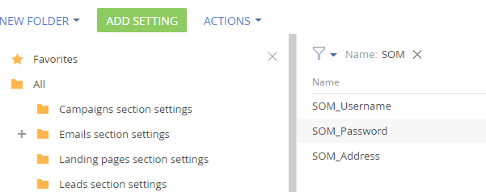

Update them as required and start working.